Eid-al-Adha
In addition to hosting prayers, mosques often function as public gathering places and social centers. The two major Muslim holidays are:-Eid al-Adha: celebrates the Prophet Abraham’s willingness to sacrifice his son for Allah.-Eid al-Fitr: marks the end of Ramadan—the Islamic holy month of fasting.Muslims also celebrate other holidays, such as the Islamic New Year and the birth of Muhammad.
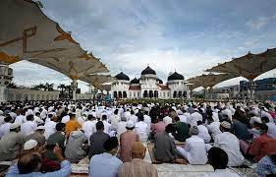
Eid al-Adha, or the “Feast of Sacrifice,” signifies the willingness of the Prophet Ibrahim, known as Abraham in Christianity and Judaism, tosacrifice his son, Ismail as ordered by Allah. It is one of Islam’s most important holidays.Usually lasting three to four days, and celebrated by millions of Muslims worldwide, the holiday begins on the 10th day of the Muslim calendar lunar month of Dhul-Hijja, at the time of Hajj, the annual pilgrimage to Mecca. Considered the holiest of the two Eids, the other being Eid al-Fitr, or “Festival of Breaking the Fast,” that commemorates the end of Ramadan, it is one of two major Muslim holidays celebrated across the globe each year.The Story of Eid al-Adha-In the Quran, Ibrahim has a dream in which Allah commands him to sacrifice his son, Ismail, as a sign of obedience to God. In the writing, Shaytaan, or Satan attempts to confuse Ibrahim and tempt him to not go through with the act, but Ibrahim drives him away.However, as Ibrahim is about to kill Ismail, Allah stops him, sending the Angel Jibreel, or Gabriel, with a ram to sacrifice instead. The commemoration of the Adha, which is Arabic for sacrifice, takes place on the final day of the Hajj pilgrimage, the fifth pillar of Islam.How Eid al-Adha Is. elebratedBecause Ibrahim was allowed to sacrifice a ram instead of his son, Eid al-Adha is traditionally celebrated on its first day, by those with means to do so, with the symbolic sacrifice of a lamb, goat, cow, camel or other animal that is then divided into threes to be shared equally among family, friends and the needy.Muslim worshippers typically perform a communal prayer, or ṣalāt, at dawn on the first day of the festival, attend Mosque, donate to charities and visit with family and friends, also exchanging gifts.

In addition to hosting prayers, mosques often function as public gathering places and social centers. The two major Muslim holidays are:-Eid al-Adha: celebrates the Prophet Abraham’s willingness to sacrifice his son for Allah.-Eid al-Fitr: marks the end of Ramadan—the Islamic holy month of fasting.Muslims also celebrate other holidays, such as the Islamic New Year and the birth of Muhammad.
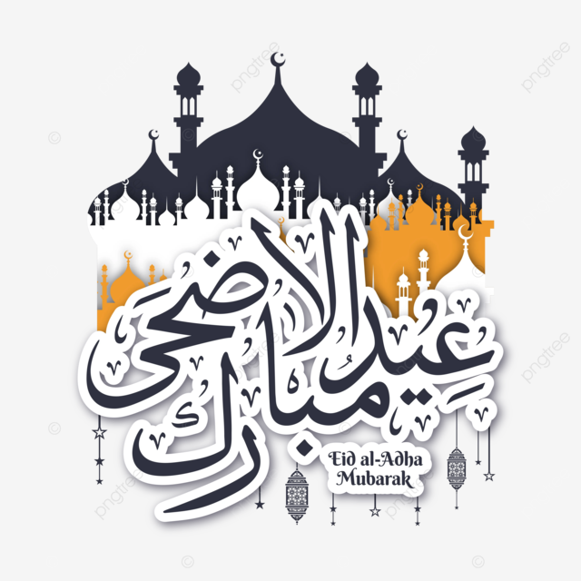
Eid al-Adha, or the “Feast of Sacrifice,” signifies the willingness of the Prophet Ibrahim, known as Abraham in Christianity and Judaism, tosacrifice his son, Ismail as ordered by Allah. It is one of Islam’s most important holidays.Usually lasting three to four days, and celebrated by millions of Muslims worldwide, the holiday begins on the 10th day of the Muslim calendar lunar month of Dhul-Hijja, at the time of Hajj, the annual pilgrimage to Mecca. Considered the holiest of the two Eids, the other being Eid al-Fitr, or “Festival of Breaking the Fast,” that commemorates the end of Ramadan, it is one of two major Muslim holidays celebrated across the globe each year.The Story of Eid al-Adha-In the Quran, Ibrahim has a dream in which Allah commands him to sacrifice his son, Ismail, as a sign of obedience to God. In the writing, Shaytaan, or Satan attempts to confuse Ibrahim and tempt him to not go through with the act, but Ibrahim drives him away.However, as Ibrahim is about to kill Ismail, Allah stops him, sending the Angel Jibreel, or Gabriel, with a ram to sacrifice instead. The commemoration of the Adha, which is Arabic for sacrifice, takes place on the final day of the Hajj pilgrimage, the fifth pillar of Islam.How Eid al-Adha Is. elebratedBecause Ibrahim was allowed to sacrifice a ram instead of his son, Eid al-Adha is traditionally celebrated on its first day, by those with means to do so, with the symbolic sacrifice of a lamb, goat, cow, camel or other animal that is then divided into threes to be shared equally among family, friends and the needy.Muslim worshippers typically perform a communal prayer, or ṣalāt, at dawn on the first day of the festival, attend Mosque, donate to charities and visit with family and friends, also exchanging gifts.

